* Entry fee is **$200.00**
  + Checks made payable to the **St. Leonard Athletics Association**
* Parkview rules apply
* League team roster players only - No all-star or combined teams
* Teams will play 1 game per evening
* Up to 8 teams accepted per tournament
  + Bracket style tournaments will be run for tournaments with 8 teams
  + Pool or round robin style tournaments may be run for tournaments with less than 8 teams
* Estimated Start Times:
  + Sunday thru Thursday 5:00PM
  + Friday / Saturday 5:30PM
  + Times may be adjusted slightly to accommodate team scheduling conflicts
* Awards:
  + Team Trophy awarded to the Tournament Champion
  + 1st, 2nd, 3rd, and participation medals awarded to the top four teams
  + All other 5th & 6th grade participants receive participation medals

**ALL GAMES PLAYED AT ST LEONARD GYM: W173S7743 Westwood Dr, Muskego, WI**

|  |  |  |  |
| --- | --- | --- | --- |
| **Boys** | **Dates** | **Girls** | **Dates** |
| 5 | 1/9-11 | 5 | 1/31,2/4,2/8 |
| 6 | 2/18-20 | 6 | 1/28-29,2/1 |
| 7 | 2/5-7 |  |  |
| 8A | 1/24-26 |  |  |
| 8B | 1/6-8 |  |  |

**Five Reasons why your team will enjoy our tournament:**

1. **All teams guaranteed to at least 3 games**
2. **Experienced referees and scorekeepers will be controlling the action**
3. **Your team will use St. Leonard’s state of the art athletic facility**
4. **The best concessions in the area. Enjoy a wide variety of food and beverage choices.**
5. **The head coach from each team entered into the St. Leonard's Tournament gets an opportunity to sink a 3-point shot before their game on the opening night of the tournament. Sink the 3-point shot and team players all get a free Slushie after your game.**

**Reserve your spot today!** Please call, text or email to reserve and guarantee your spot:

**Tournament Director**: Mike Schepp – 414 467-1940 (Cell) -  [mjschepp@yahoo.com](mailto:mjschepp@yahoo.com)

Click [HERE](https://forms.gle/7j1JgeKGecjmLZqe8)for registration form or print and mail the form below. **Entry Fee $200 per team.**

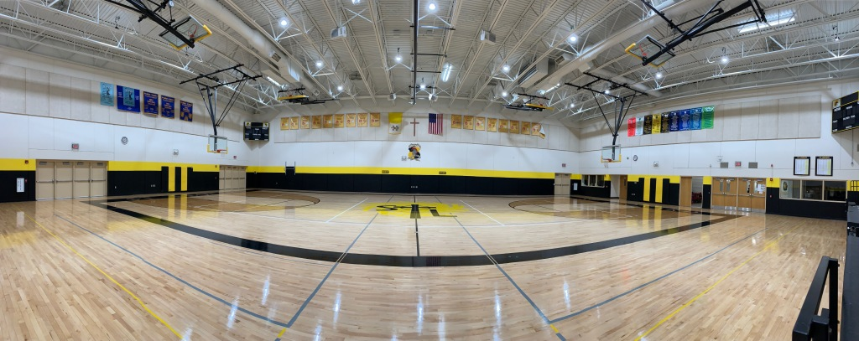

**Please submit your registration and your entry fee to the tournament coordinator:**

Mike Schepp

W151S6561 Glenbrook Dr  
Muskego, WI 53150

<https://www.stleonards.org/athletics>

mjschepp@yahoo.com

**Entry deadlines will be one week before opening night of each tournament or when brackets are filled**

School ___________________________ Team Nickname ___________________

Team Color(s) _________ / _________ / __________

Tournament (circle) Boys 5 Boys 6 Boys 7 Boys 8B Boys 8a Girls 5 Girls 6

League ___________________________________________________________

Division ___________________________________________________________

Team (If 2 teams from the same school and division i.e. St. Leonard GOLD)

______________________________________

Head Coach: Name ________________________________________________

Phone Number _____________________ Email ___________________________

Assistant Coach: Name _______________________________________________

Phone Number _____________________ Email ___________________________

Team Roster: Name of Player: (Please Print clearly) Uniform number:

1. ___________________________________________________ ___________

2. ___________________________________________________ ___________

3. ___________________________________________________ ___________

4. ___________________________________________________ ___________

5. ___________________________________________________ ___________

6. ___________________________________________________ ___________

7. ___________________________________________________ ___________

8. ___________________________________________________ ___________

9. ___________________________________________________ ___________

10. ___________________________________________________ ___________

11. ___________________________________________________ ___________

12. ___________________________________________________ ___________

Please list any and **ALL** conflicts:

__________________________________________________________________

**Reminder**: Please check your calendars carefully; Archdiocese rules prohibit teams from playing more than 2 games per day. (This includes league and tournament games).